# Metaverse standard API

Foreword:

Meta universe is an extremely open, complex, and huge system. It covers the entire cyberspace and numerous hardware devices and realistic conditions. It is a super-large digital application ecosystem jointly constructed by multiple types of builders.

Brief description of API interface background:

We have completed projects such as social networking sites, short video recommendation systems, and Internet of Things (large-scale online nodes) covering the Internet, network connections, and communications. In-depth exploration of science fiction film and television works and the world of science fiction (Earth Baizi, Black Mirror, The Matrix, etc.), with more than ten years of programming experience, with ideas, capabilities, and vision to complete the meta-universe interface design work of this historical mission.

API interface concept:

* Efficient, concise, convenient for transmission, analysis, code implementation, human reading
* Scene normalization, with more dimensions and rich media information
* Can be upgraded, expanded, advanced interface implementation can automatically learn the latest version of the protocol
* Design exclusive interfaces for multiple fields (interaction, Internet of Things, VR, AR, etc.)
* Intelligent conversion, auto-negotiation, can automatically adjust and convert the interface data according to the data receiver
* Can obtain detailed information of the object, can query the status, surrounding objects and access method

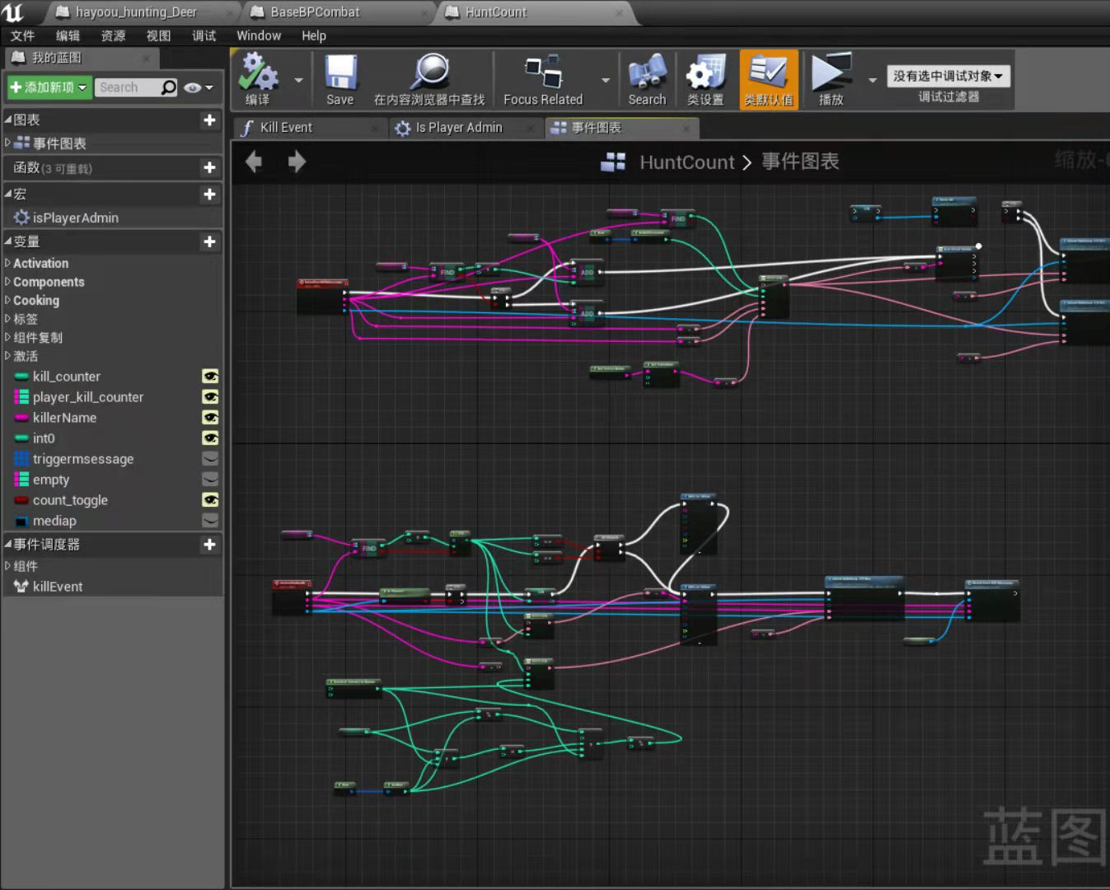

Screenshot of meta universe world design

API interaction process:

1. Send basic query instructions to obtain basic information about the connected object.
2. According to the minimum supported API version number (meta_api_ver_min), confirm the interaction capability. If it cannot be satisfied, it can automatically obtain the basic information primitive description of the version of the API , and obtain the visible data segment and the interactive functional interface.
3. According to the agreement, send and receive relevant data interaction

Detailed documentation:

﻿[Metaverse General Protocal Metaverse General Protocol](https://docs.qq.com/doc/DS3lxV2F3UWtnQmlG)﻿

﻿[Metaverse API basic information primitive description(schema) V1.0](https://docs.qq.com/doc/DS2xPZEhDZU5Bd2Fn)﻿

Cooperatively register the Universe Universe Identifier:

﻿https://docs.qq.com/sheet/DS21mUEtNYUhEVENU﻿

resource:

Meta universe access guide and resource list (updating, group collaboration)

﻿https://docs.qq.com/sheet/DS29ZYVRSVEpuVHFl﻿

API server open source code:

﻿https://gitee.com/hayoou/metaverse_api_server_go﻿

Meta universe basic API interface (you can obtain other node information through this server to traverse the meta universe):

<http://sg.zyinfo.pro:8081/api>﻿

Meta Universe API Specification_Technical Document (Offline Version) V1.0

[﻿https://pan.baidu.com/s/1ynV8wJm-Rudqoilfyz9i5A](https://pan.baidu.com/s/1ynV8wJm-Rudqoilfyz9i5A) ﻿

Extraction code: 5566

﻿

Welcome to participate in API document collaboration, supplement and improve related interface content, WeChat youkpan,youkpan@gmail.com